**How to connect to PI via FTP using FileZilla**

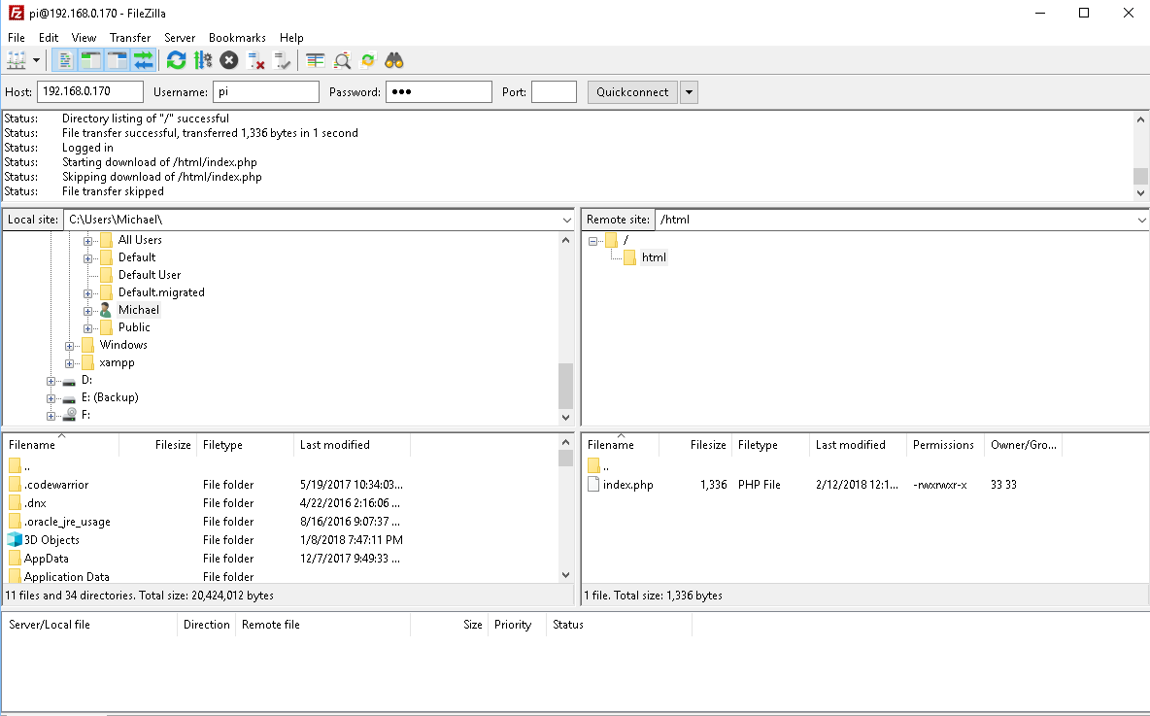

**Host:** IP address of the PI (192.168.X.XXX) – get via ‘ifconfig’ in the terminal of the PI - your computer

must be connected to the same wireless network (i.e. the Elevator Network) as the Raspberry Pi

**Username:** pi

**Password:** ese

**Port:** 21 (for ftp)

Once connected you can transfer files to the Raspberry PI

**Note:**

In the folder /var/www/html/ on the Raspberry Pi you will find a sample webpage (index.php) for controlling the elevator.

To allow index.php to control the elevator you must run the program located on the Desktop of the Raspberry Pi. To do this go to the terminal and type

$ cd ~/Desktop

$ cd pcan-database_sample_project

$ cd src

$ ./main

Choose option 3 to listen for commands from the webpage.

**How to connect to PI via SSH using PuTTY**

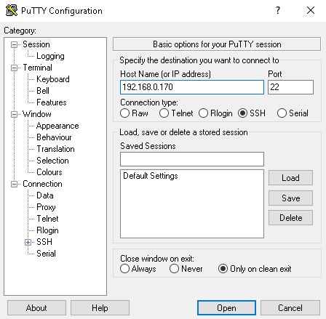

1. Enter IP address of the PI (from ‘ifconfig’ in terminal): 192.168.X.XXX
2. Port should be 22 (SSH)
3. Click open
4. At the prompt enter:



* 1. **Username:** pi
  2. **Password:** ese

1. You now have remote terminal access to the PI (likely you will need a laptop to connect wirelessly to our subnet).

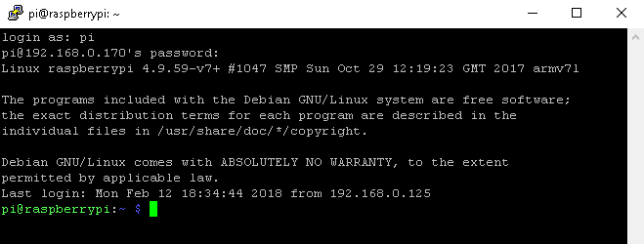

1. You can now do anything you would need to do locally (e.g. access your mysql database)

